

**Lab Manual**

**Computer Engineering – Artificial Intelligence**

**B. Tech. Year – II, 5th Semester, Academic Year (2023)**

**Subject Code: 01AI0501**

*Subject Name: Advance Java programming*

*Name: Basid Al Siddik Shammo*

*Enrollment Number: 92100151052*

**PROGRAM-01:** A Simple Framed Window.

**CODE:**

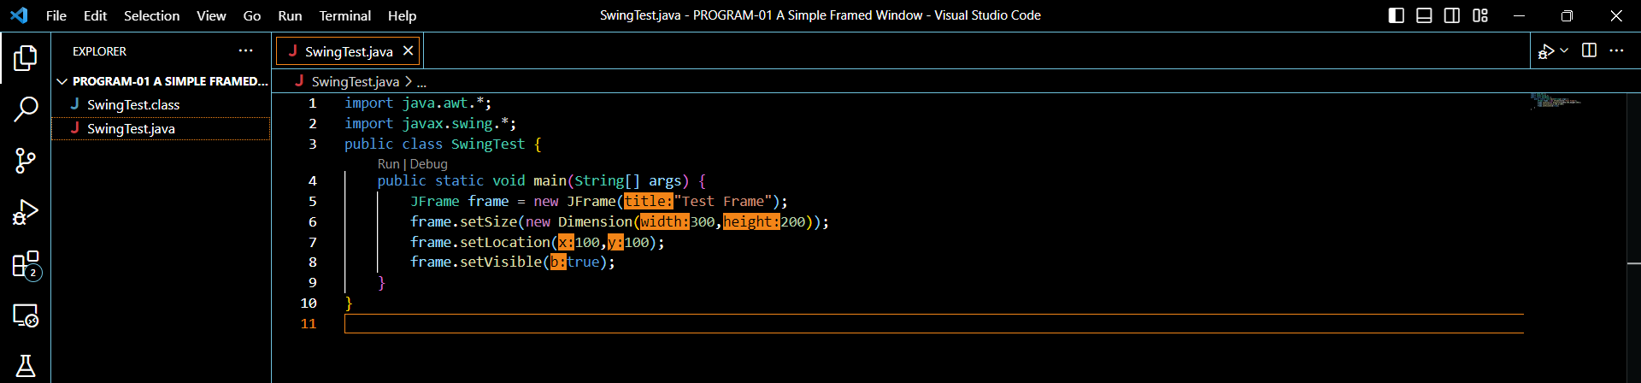

**Result-**

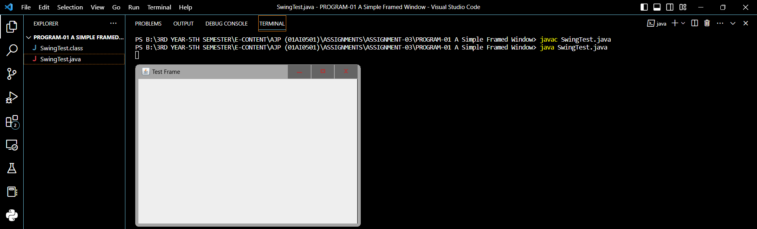

**PROGRAM-02:** Changing Background Color.

**CODE:**

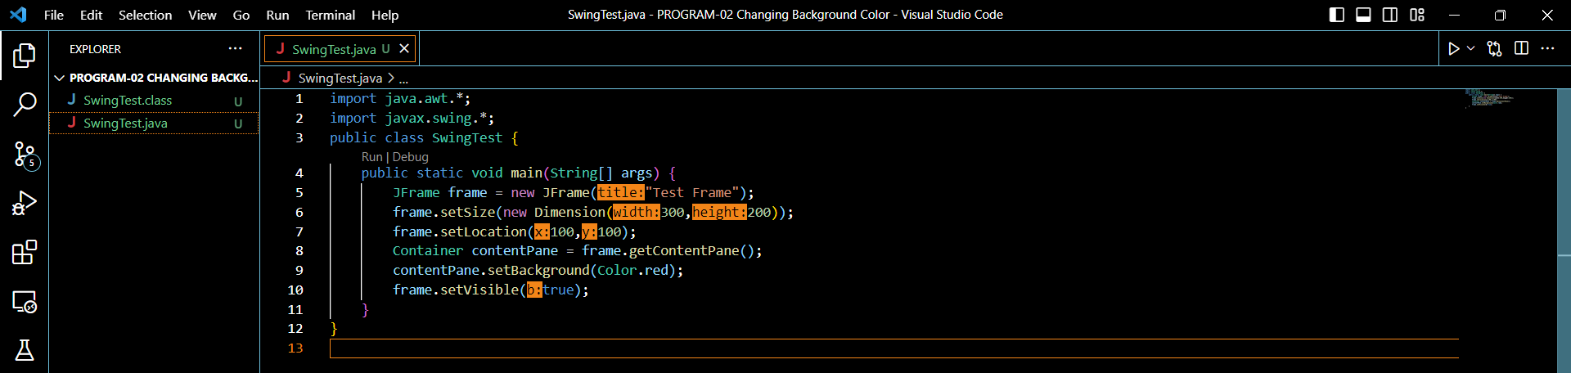

**Result-**

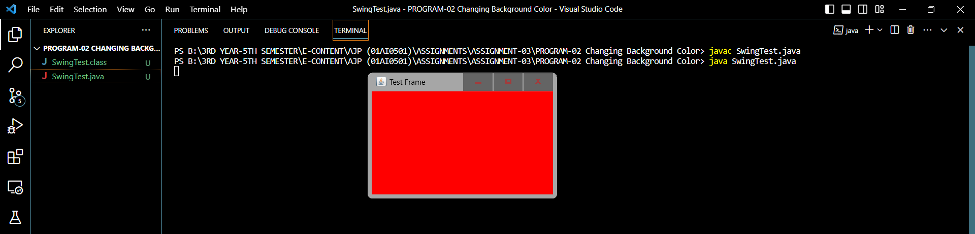

**PROGRAM-03:** Adding a Label and Button.

**CODE:**

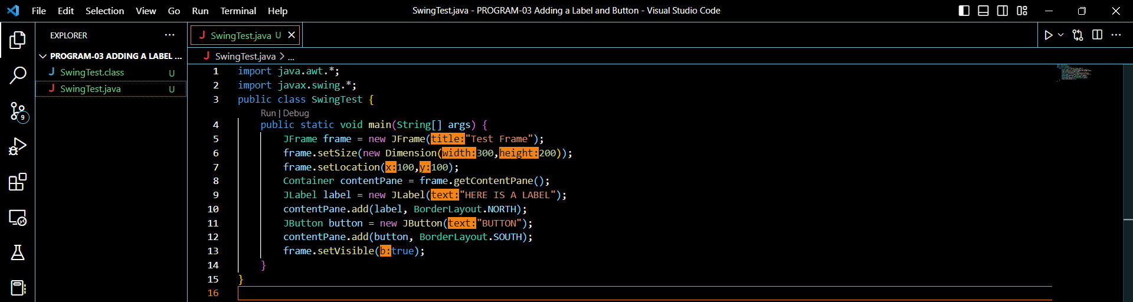

**Result-**

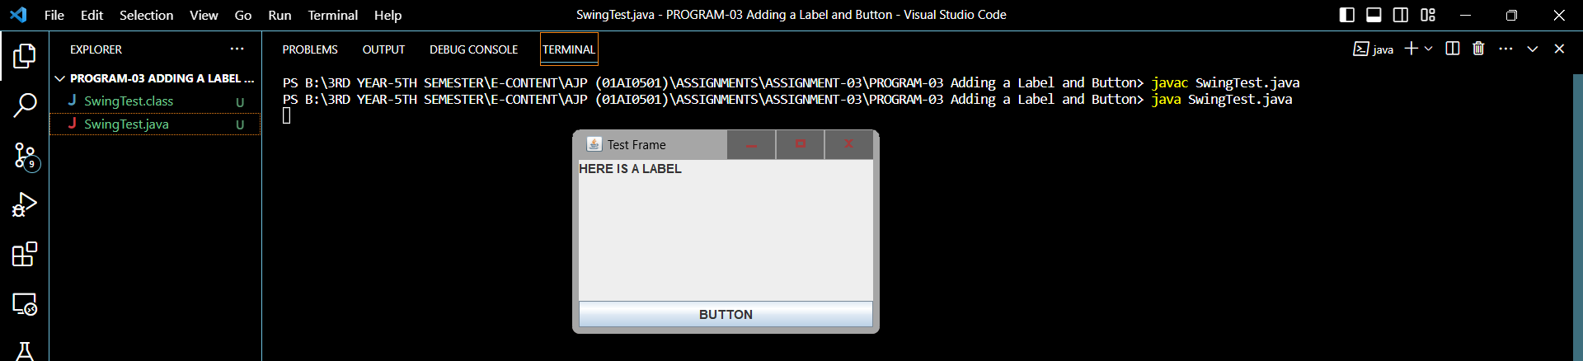

**PROGRAM-04:** Adding a List of Options.

**CODE:**

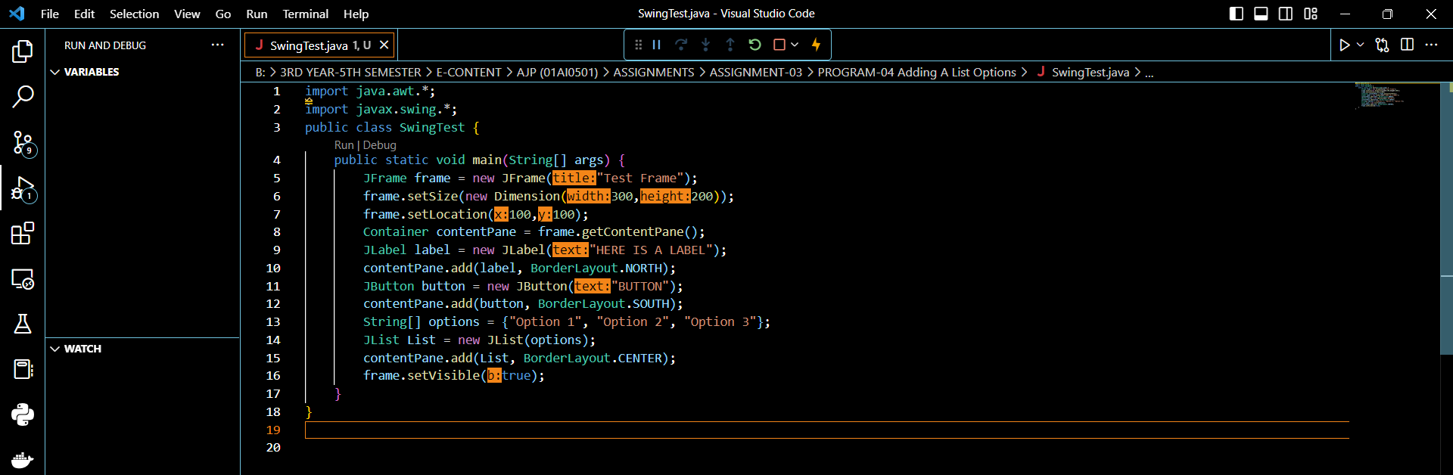

**Result-**

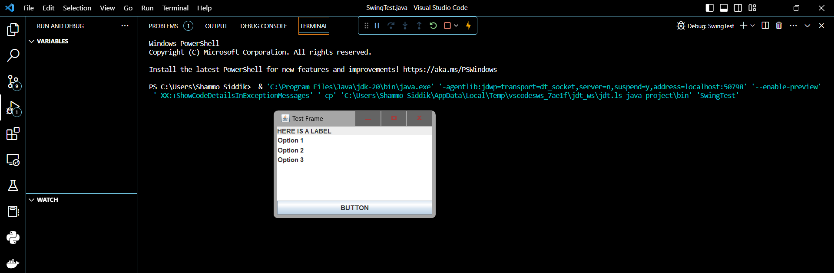

**PROGRAM-05:** Adding a Check Box and Slider.

**CODE:**

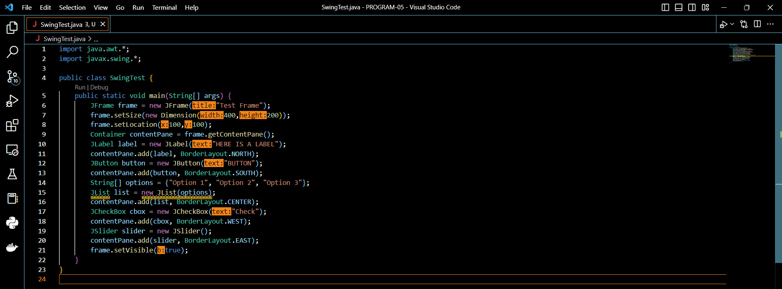

**Result-**

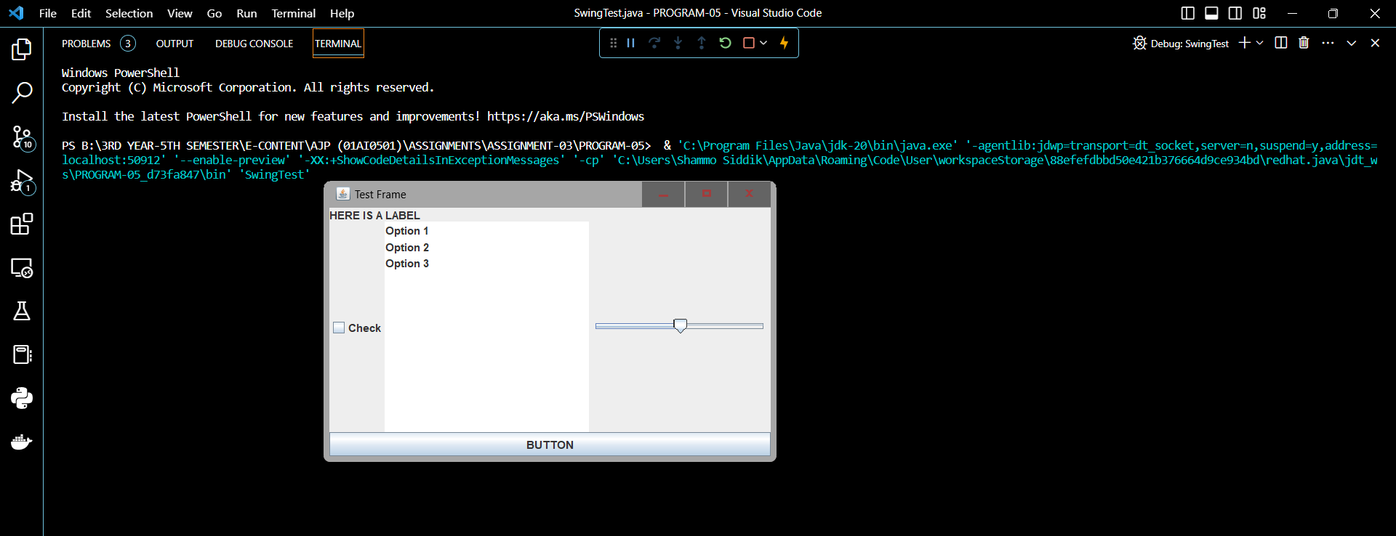

**PROGRAM-06:** Changing the Layout.

**CODE:**

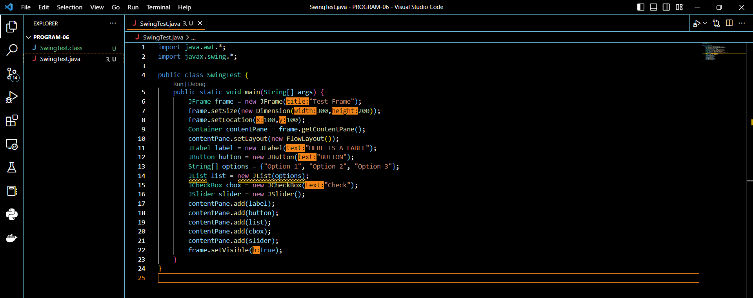

**Result-**

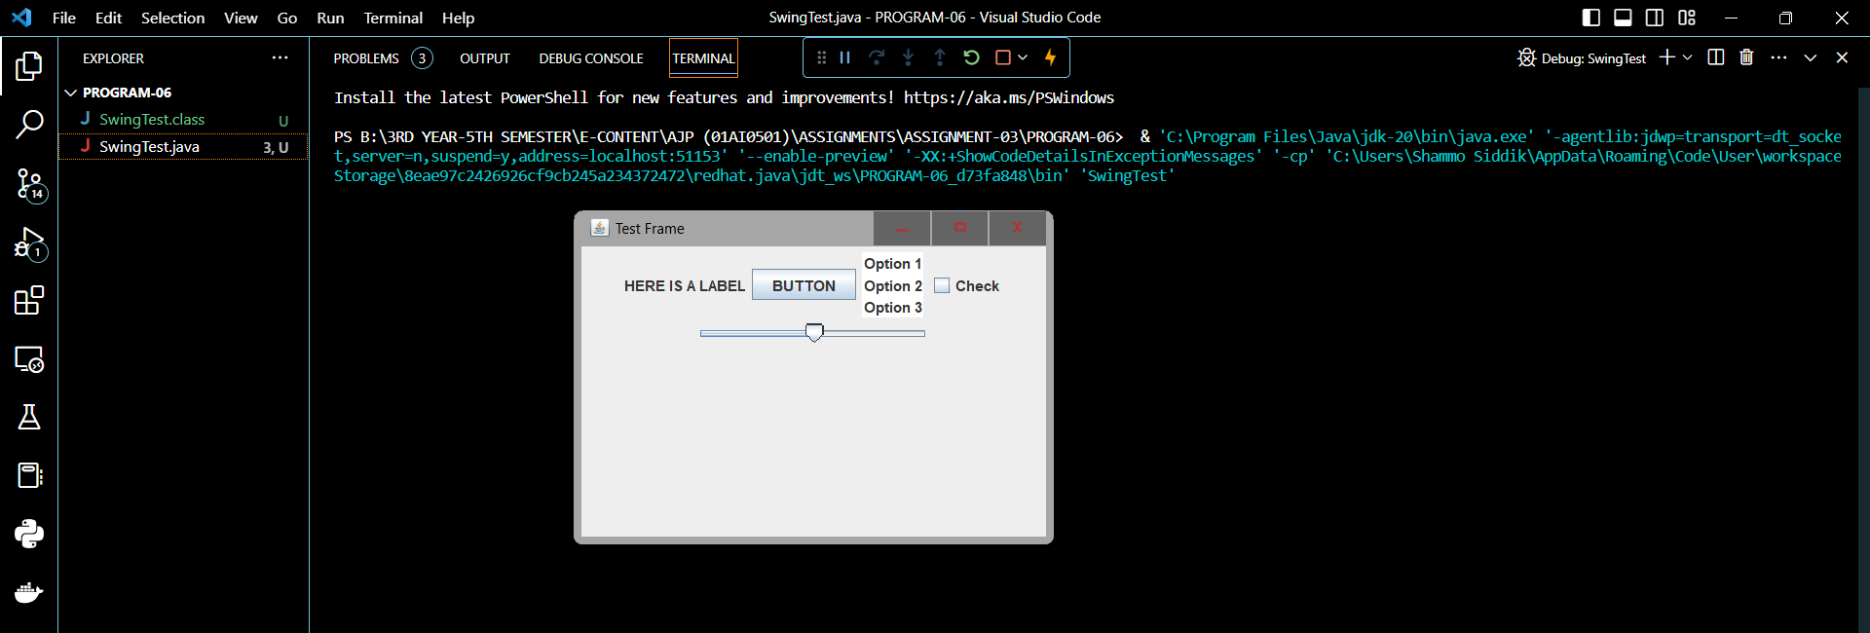

**PROGRAM-07:** JPanel Example

**CODE:**

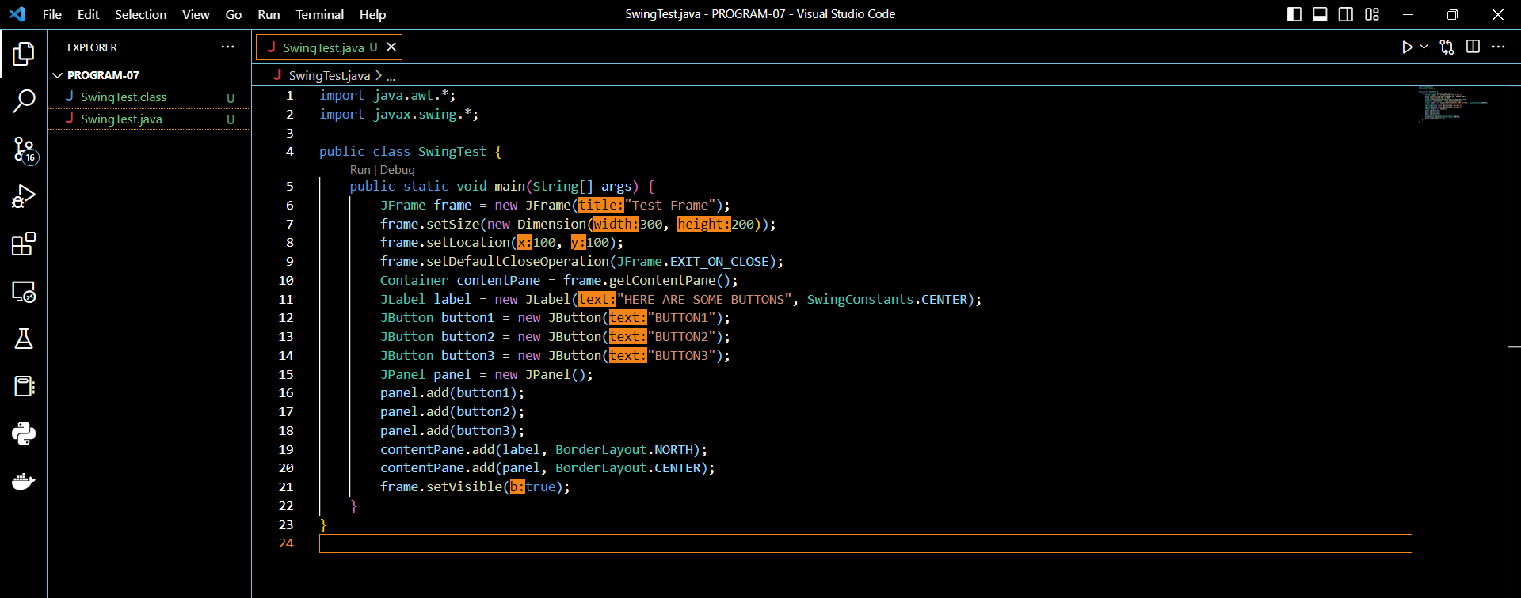

**Result-**

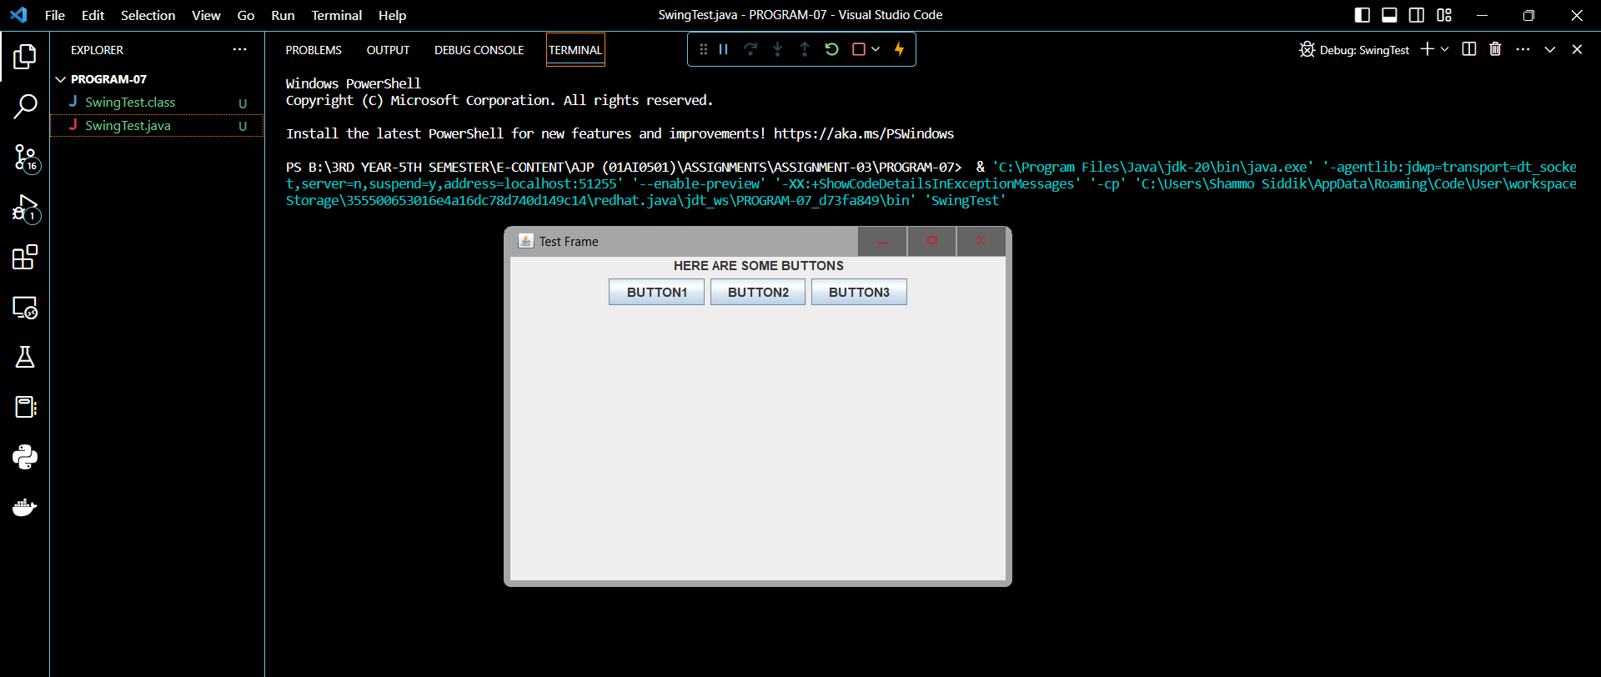

**PROGRAM-08:** Changing JPanel Layout

**CODE:**

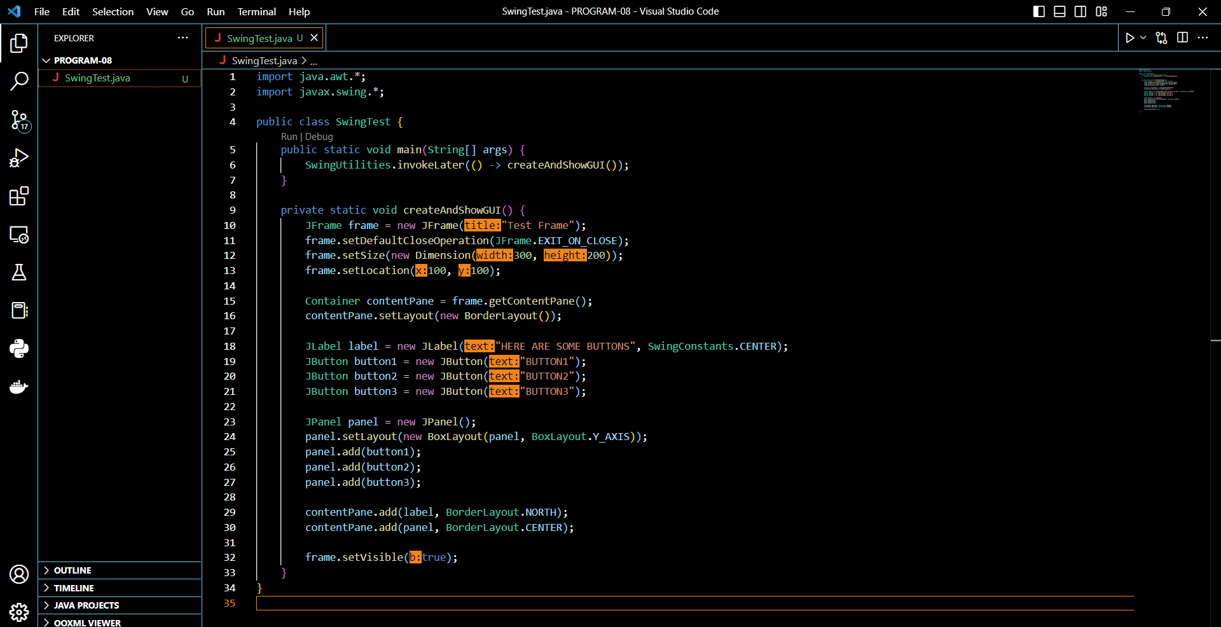

**Result-**

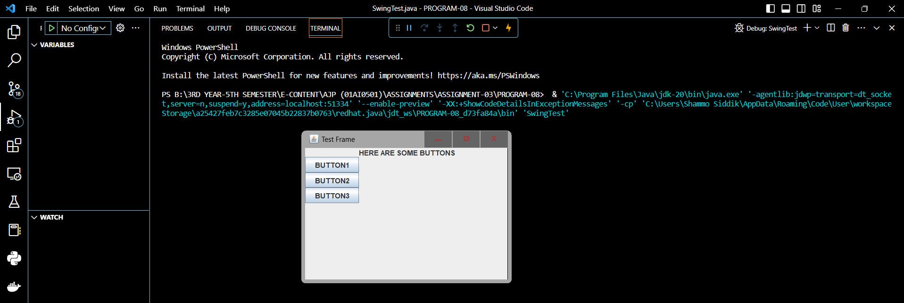

**PROGRAM-09:** Tweaking Example.

**CODE:**

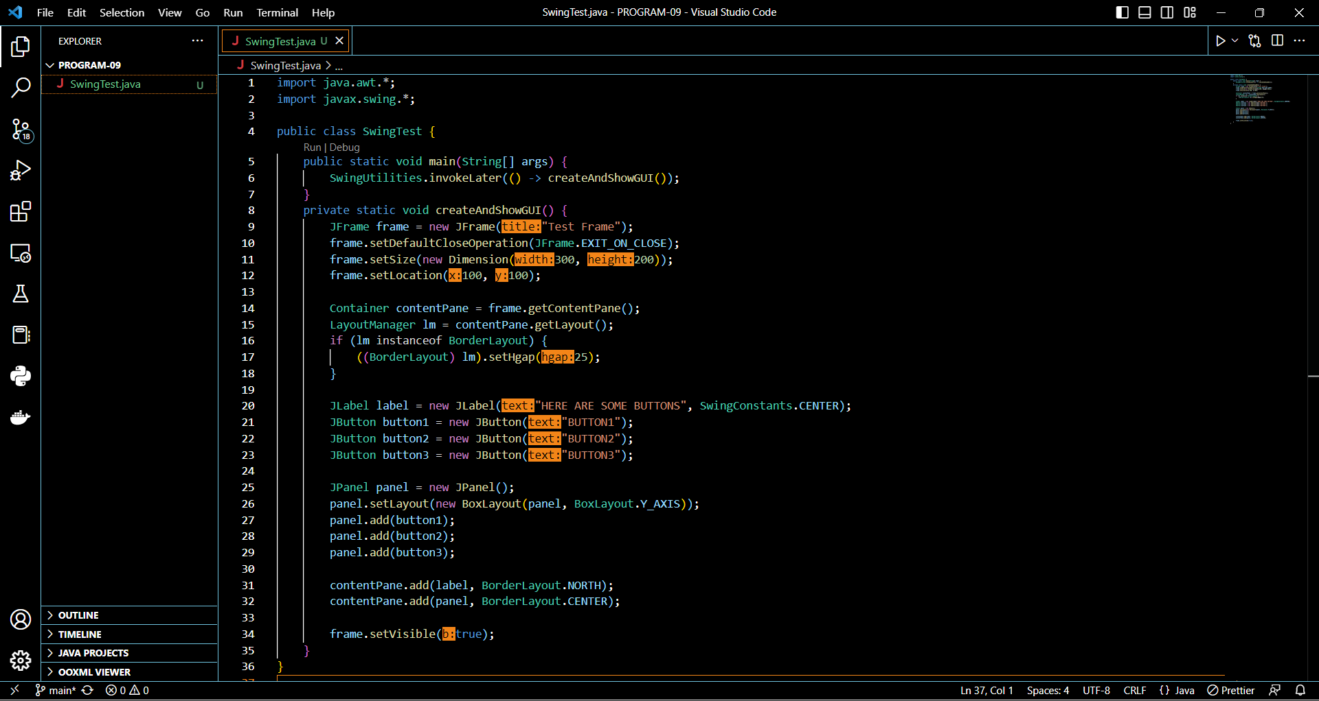

**Result-**

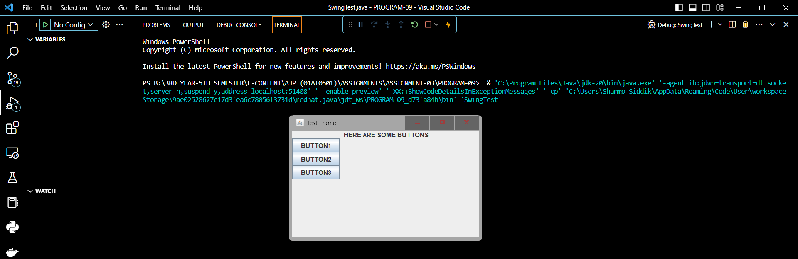

**PROGRAM-10:** Containment Hierarchy of a Menu.

**CODE:**

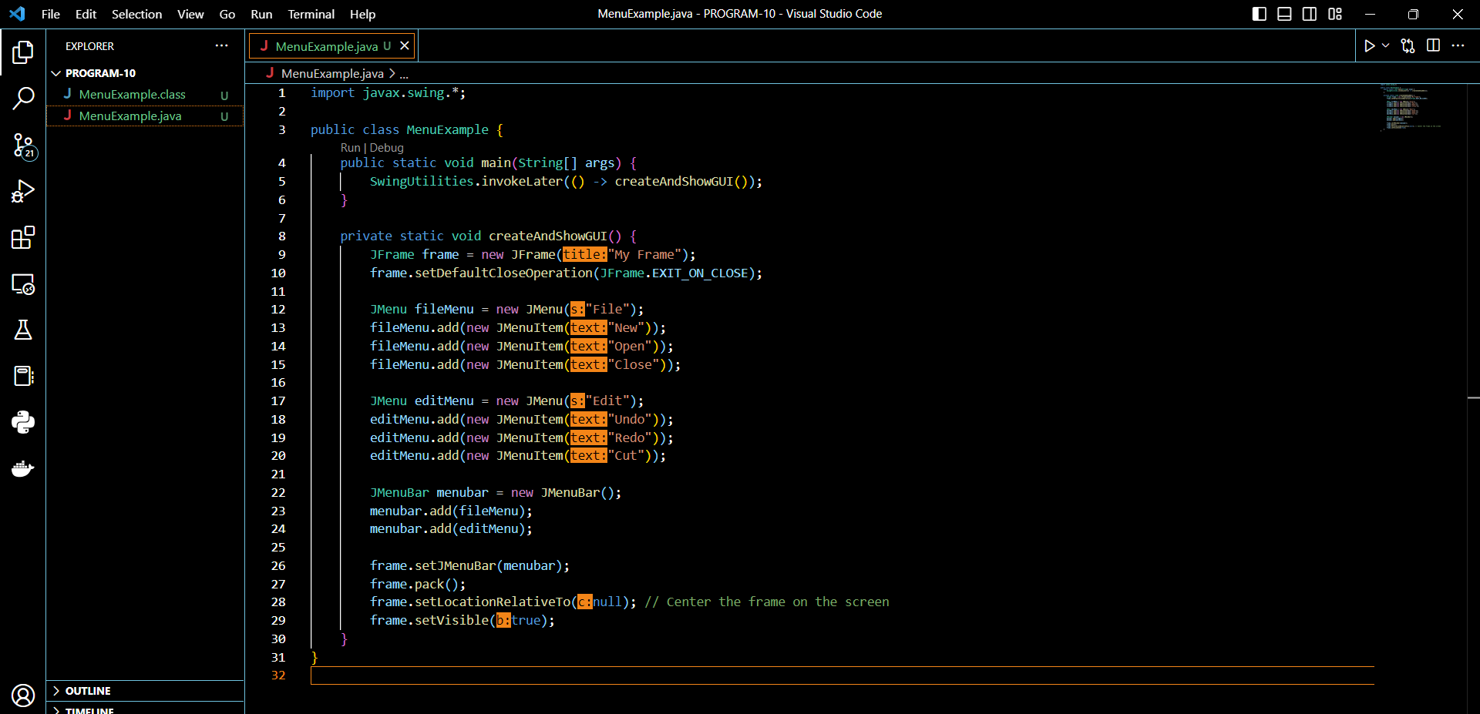

**Result-**

